Journal #5
Louis Harshman – WaveSpeak
Goals and reflection:
- Compile the tablet software.
  - After installing several different Debian and Ubuntu versions and switching to the newer DietPI OS on my raspberry PI allowed for a reliable build chain that I can use on a regular basis.
- Create a software development plan for the project.
  - Made a Trello and I am adding features daily.
- Decide on how to display button elements in html.
  - I am doing a 1-dimensional array to matrix data structure to display the elements.
- Develop the button objects and layout.
  - Represented in a JavaScript class (see OOP patterns https://en.wikipedia.org/wiki/Object-oriented_programming), buttons are built from a manifest file called JSON (JavaScript Object Notation). When the app is loaded, it will read this JSON and build an array to read from on app load.
- Develop Button to backend calls.
  - I am just using a JavaScript feature called “EventListener” that adds behavior to an element that is executed when an event occurs (e.g. clicked, hovered, loaded).
- Try to add icons to buttons.
  - Used the JSON manifest to store paths to images. This is important as if I stored every image for every chip, memory usage would be insanely high for this app. I currently have it down to ~80 Megabytes at idle. For reference, a default chrome browser with google.com loaded uses ~117 megabytes so I’m doing pretty good regarding space complexity.
- Make Text to speech sound more natural.
  - Working on implementing coqui-tts (https://github.com/coqui-ai/TTS). The biggest issue I’m having is that it is a python library, and my application is written in rust. This is solved by something called “bindings” which allow me to easily execute python from my rust code.
- Add action buttons.
  - Action buttons are implemented and will always take up the bottom row.
- Add behavior to the visor.
  - The visor can now hold buttons and you can click every button to speak that word in the visor.
Reflection on Timeline:
I have struggled quite a lot on the manufacturing and design of the tablet because It’s not my strong suit. I am far more familiar with software development and patterns.
This has put me behind quite a lot on the timeline and I had to cut my development time by three quarters.
Accomplishments:
- The Entire software foundation/architecture is set up and ready for features to be added.
- The case is fully designed and ready for the final assembly.
- 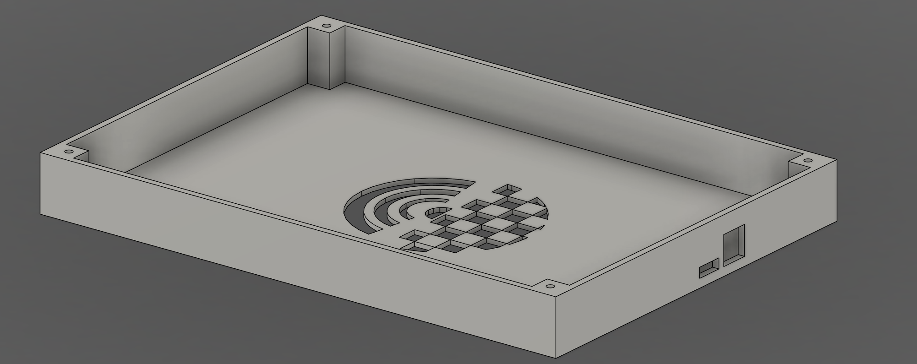
- 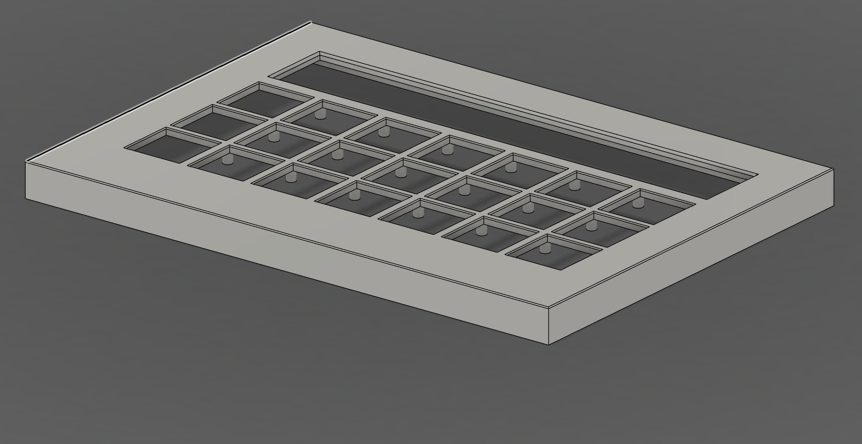
My Research and What I learned:
I have learned the following topic general and specific topics.
- Manufacturing tolerance
  - I learned about the unforgiving tolerances I must meet to make this project’s form factor possible. Designing is the easy part, but manufacturing is the hard part and I have had to redesign to ensure that this tablet is actually possible to make.

