Journal #3

Louis Harshman – WaveSpeak

Goals and reflection:

1. 3D print button negative mold
2. Decide on the epoxy to be used
3. Research software solutions
4. Work on button prototype
5. Look into manufacturing techniques for clear plastic
6. Research software solutions
7. Get back into working on this project
8. Build PCBs
9. Program PCB microcontroller

Reflection on Timeline:

I am a little behind on my timeline due to hardware and I will have less time for software related development. But I have accounted for this and left a couple weeks open in the schedule for this exact circumstance.

Accomplishments:

(Image of my entire assembled PCB)

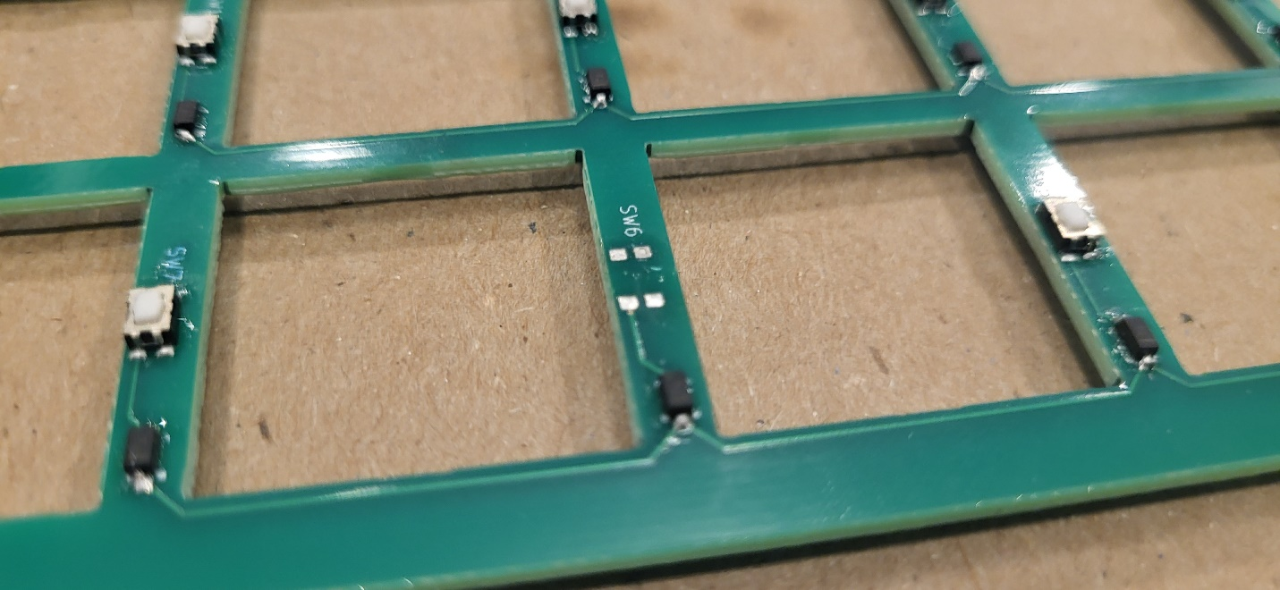

(The pads before soldering a button on)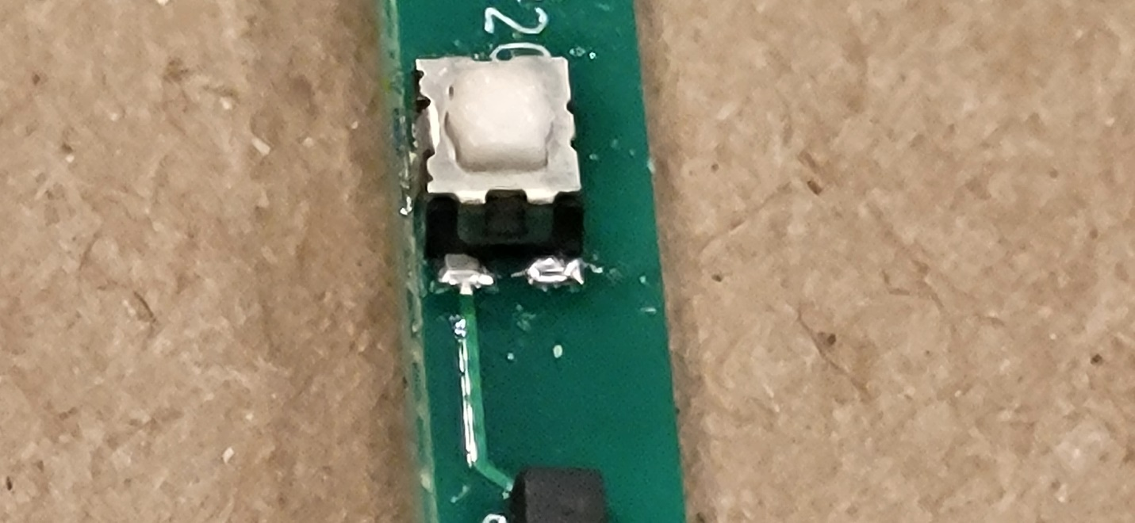

(The pads after soldering a button on)

I pretty much only built the PCB and got it fitted into my case. I used a solder paste and a hot air gun to solder the parts and to mostly avoid soldering all 126 individual pads on the board. The solder paste allows me to place all the parts with a taky paste that holds the button down until I heat them up to 265° Fahrenheit to fully solder them to the board.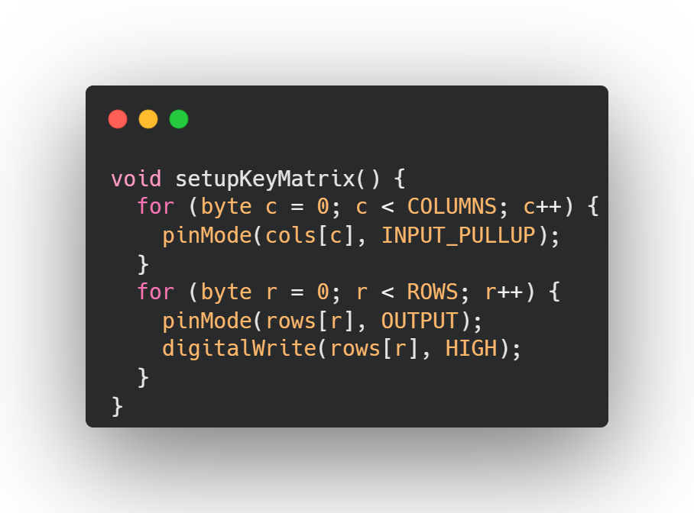(Code responsible for scanning for and reading key input)

My Research and What I learned:

1. Hardware
   1. I learned more about the soldering process after minimal research into surface soldering methods. This allows my product to be smaller, slimmer, and more functional.
2. Software
   1. I have no clue what software I’ll be using for the tablet. I was thinking about FullPageOS but that is very limiting due to it ultimately being a web browser which has a lot of limitations for security reasons.