Journal #2
Louis Harshman – WaveSpeak
Goals:
- Get PCB design started and ready for integration with cad model.
- Research software for switch backplane microcontroller.
- Have PCB ready for manufacturing by Friday!
- Get 3D STL models finalized for Mr. Combs to print.
- Review overall product and ensure integration will work.
- Purchase another inland pro-micro due to unforeseen... I broke the pro-micro by ripping the USB port off.
- Fix printing issues
- ORDER PCBs
- Finish getting switch handler program finished.
Reflection on goals and Timeline:
I’ve yet to order the PCB due to design changes but I plan on ordering them on the 20th of December. I am behind on the timeline, but I am making a great amount of progress, so I am not worried at all. I will need to adjust the timeline due to delays in production. I’ll probably drop 2-3 weeks.
Accomplishments:
I got the PCB backplate and back case finished which I am proud of. The 3d print came out really accurate, and it fits my display!
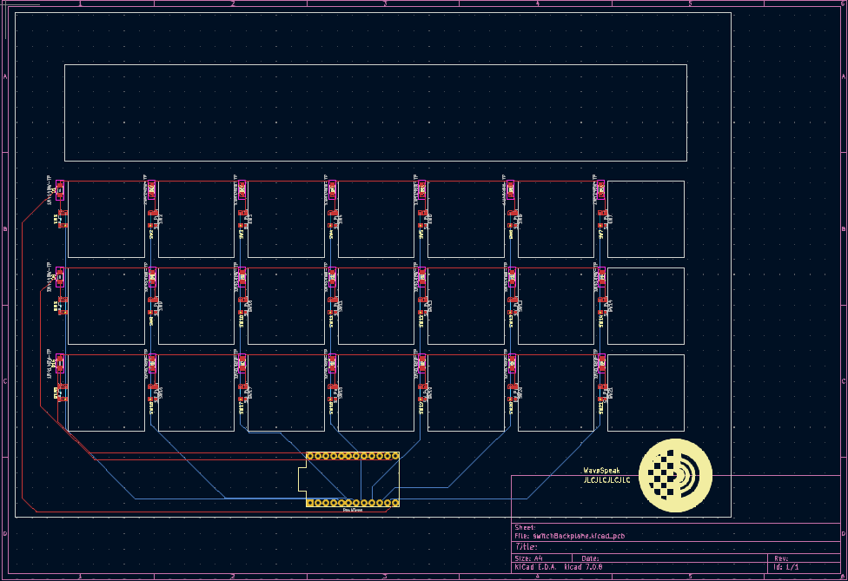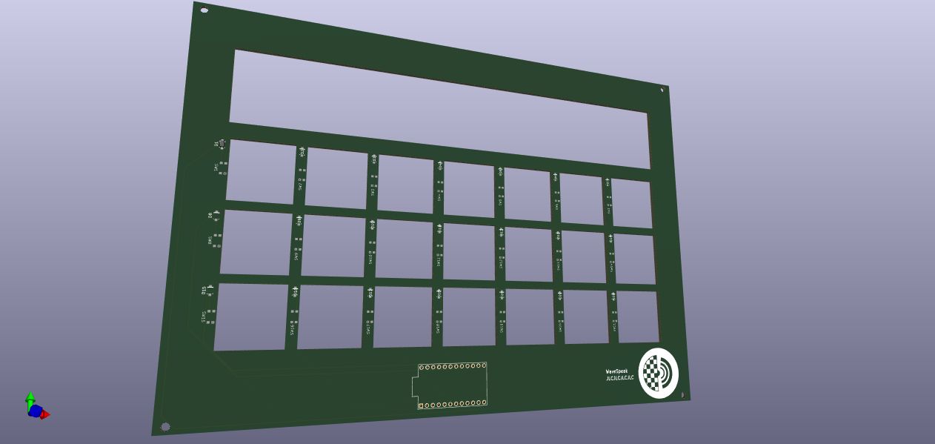

The tablet is now running FullPageOS which is a useful kiosk type of OS that serves static HTML websites.

My Research and What I learned:
I focused my research mostly on PCB design and standards. I also learned more about good OSes for the raspberry pi. Here are all the PCB design related videos I’ve watched to learn how to make the KiCad schematics.
https://youtube.com/playlist?list=PL5JVfKgqlUh4Db6WbDxrnOfeUj1j-ZTqX&si=muedXBRYDA-DDMau
I have learned the following topic general and specific topics.
- Electrical engineering
  - Diodes
  - Key matrixes
  - Micro Controllers
  - PCB Design and manufacture
- Programming/Software architecture
  - Arduino programming
  - C++ Programming
  - Web Development
  - Linux Embedded development
- Hardware design
  - 3D printing tolerance
  - Slicing design

